AI Job Marketplace Demo Documentation | AI 招聘市场 Demo 文档
English
1. Architecture
This demo is built with Next.js App Router as a full-stack web app.
- Frontend: Next.js, React, custom CSS
- Backend: Next.js Route Handlers
- Database/Auth: Supabase
- AI Integration: OpenAI API
- Deployment: Vercel
Main modules:
- Authentication: login/signup/session handling
- Dashboard: job matching and job list
- Job Management: create, edit, delete, detail view
- Profile: display name, email, skills
- AI Feature: generate skills from job description
2. Features
- Email/password authentication
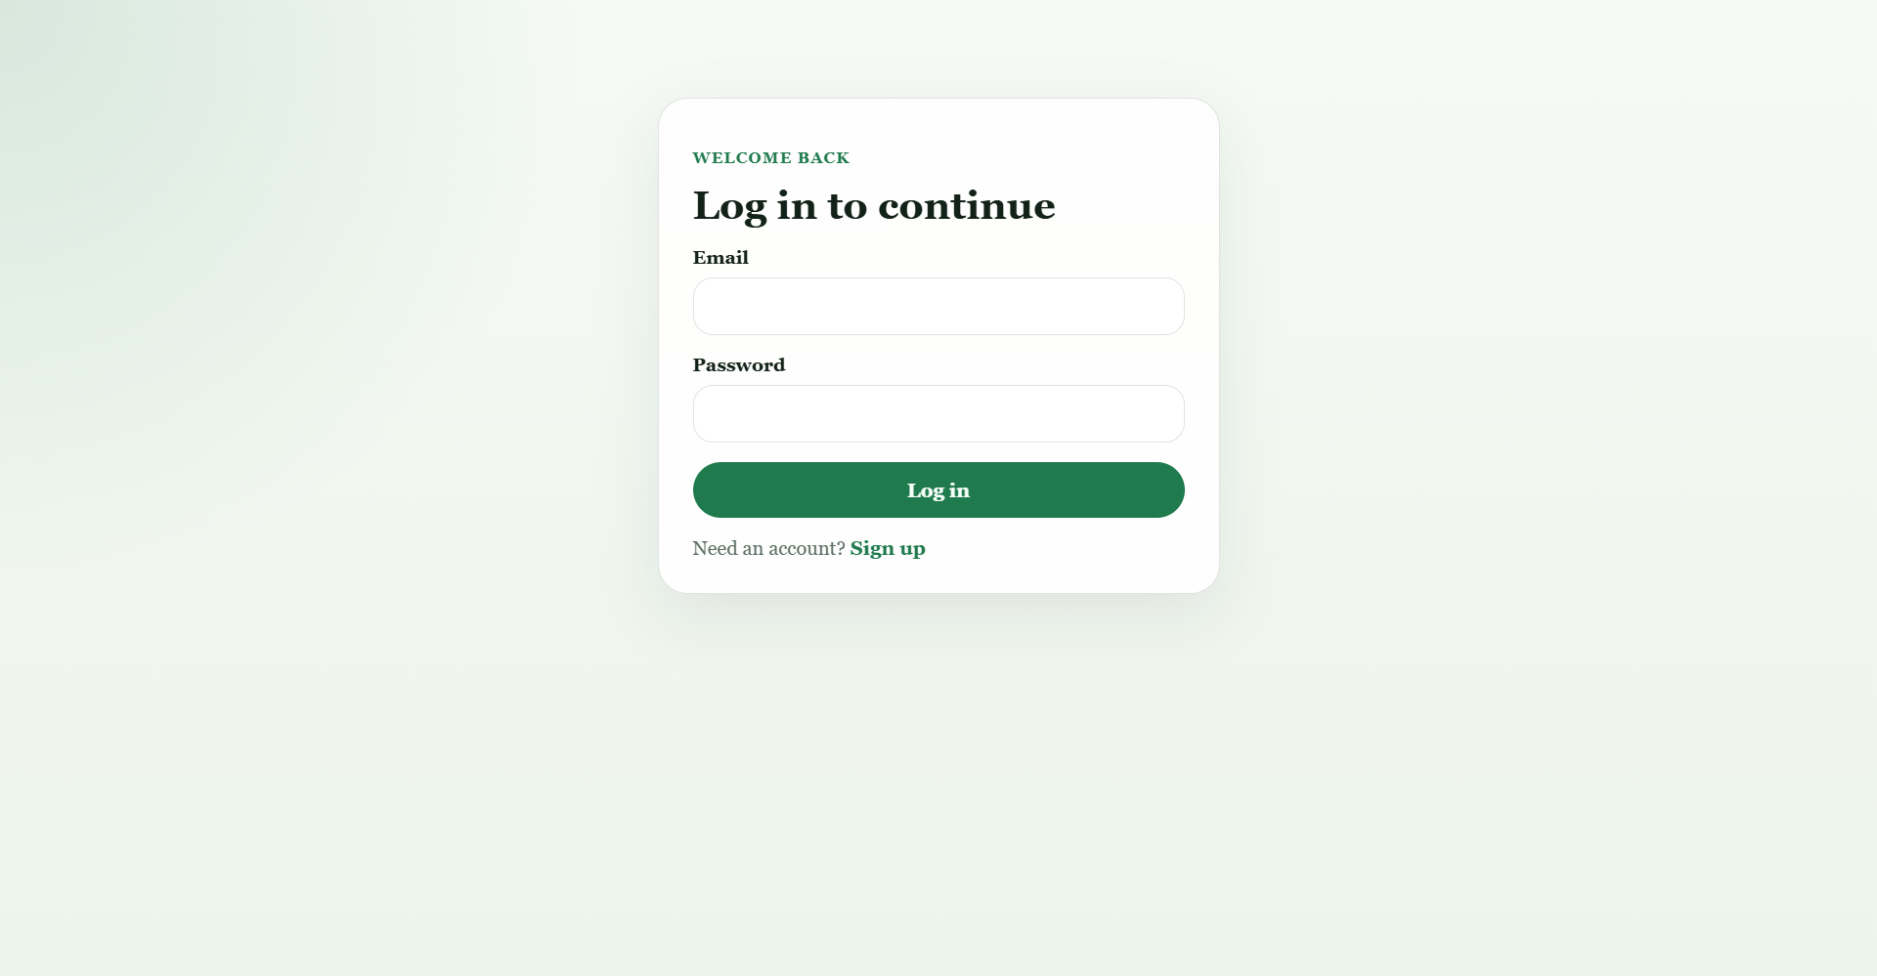
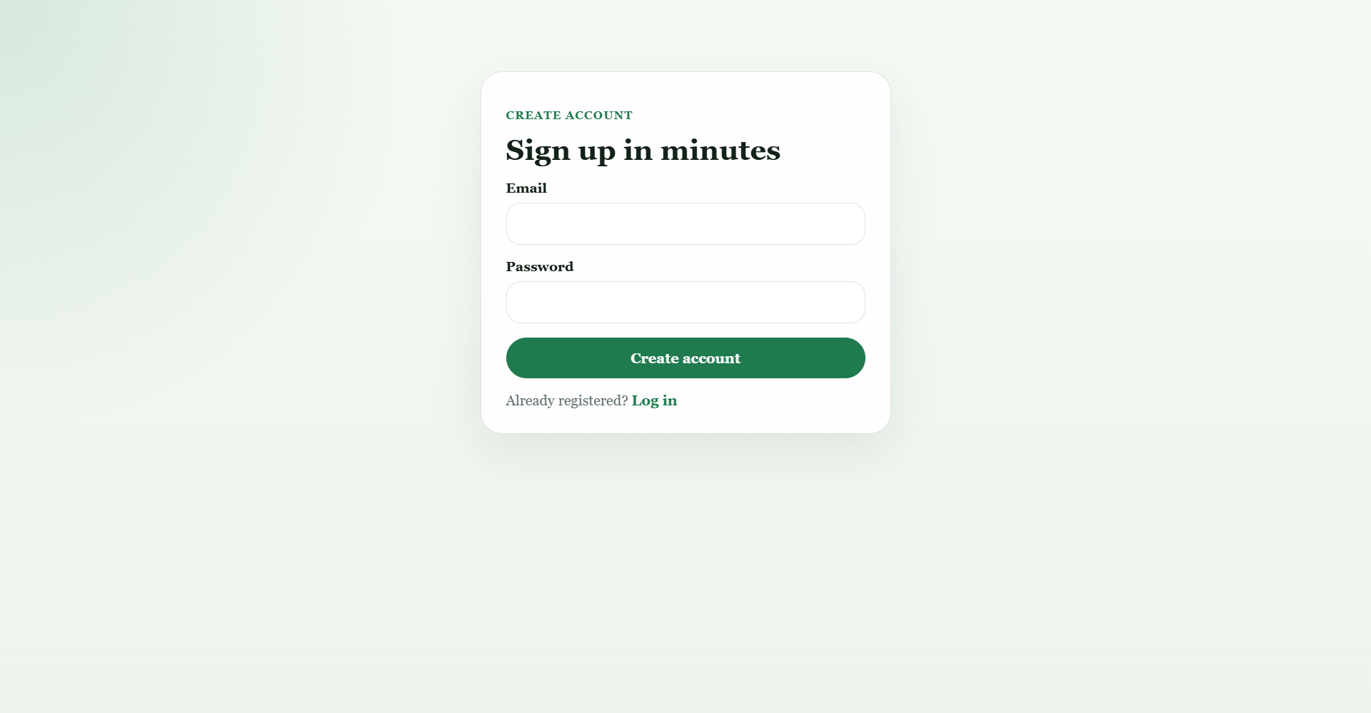
- Employer can create, edit, and delete jobs
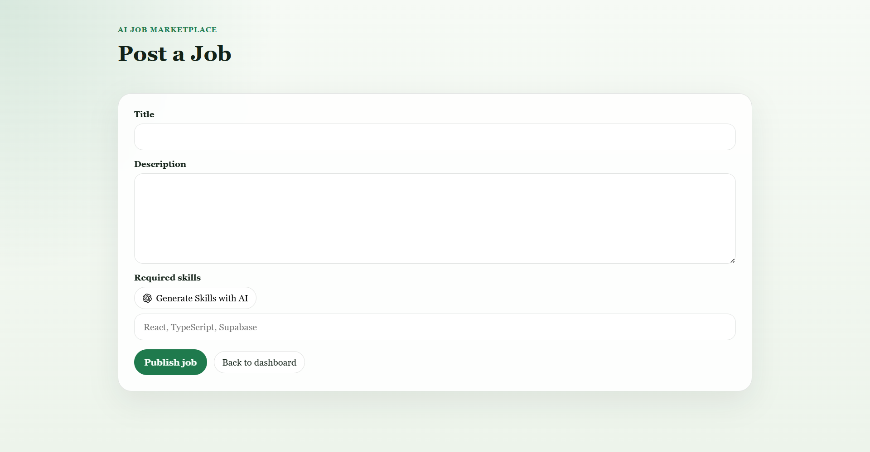
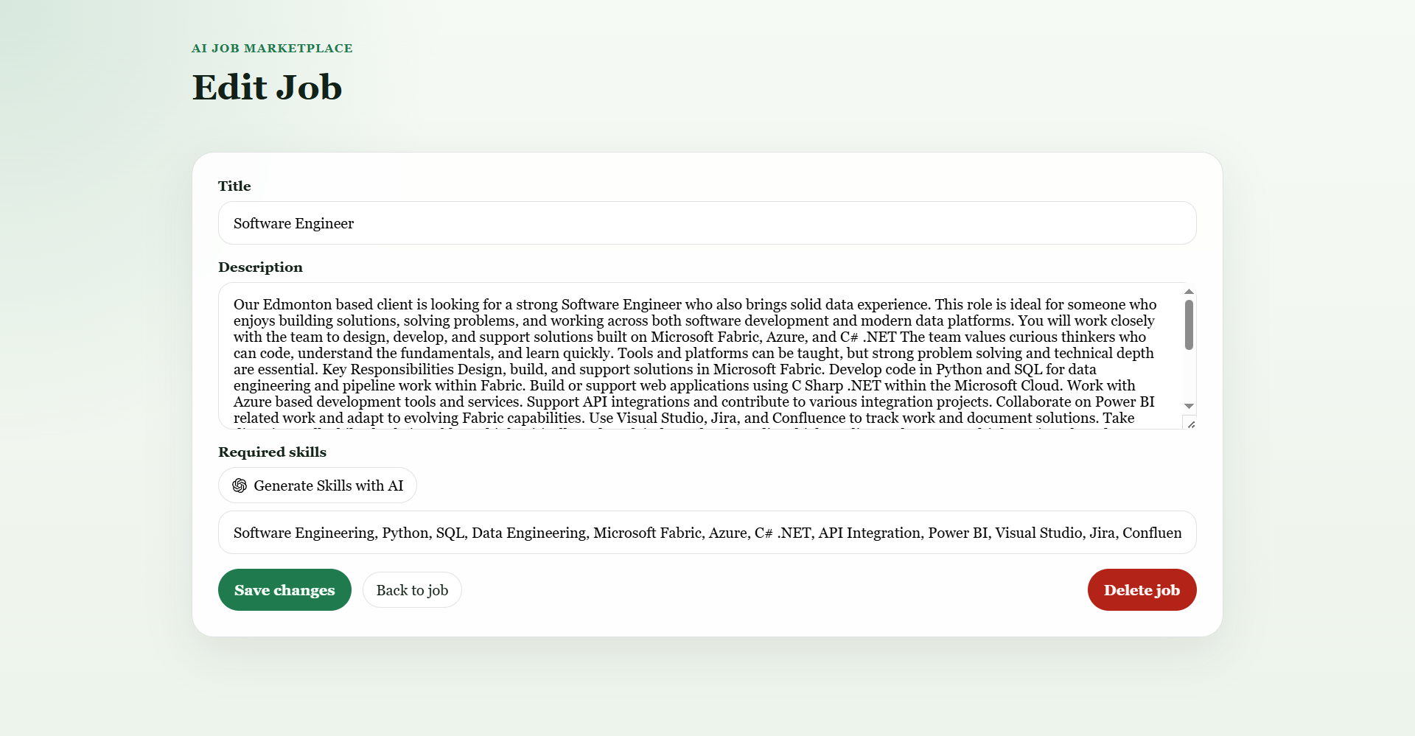
- Jobseeker can browse job cards and job details
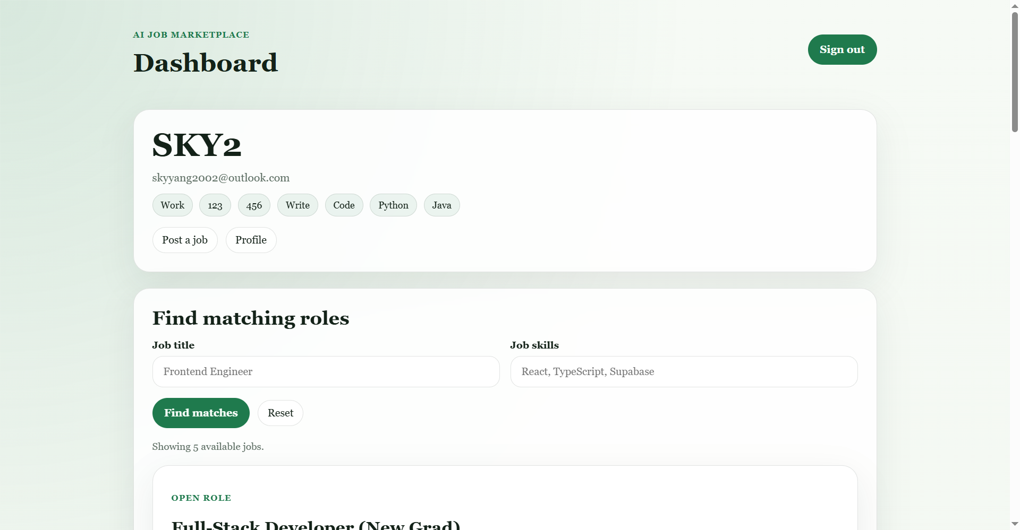
- Profile page with editable display name and skills
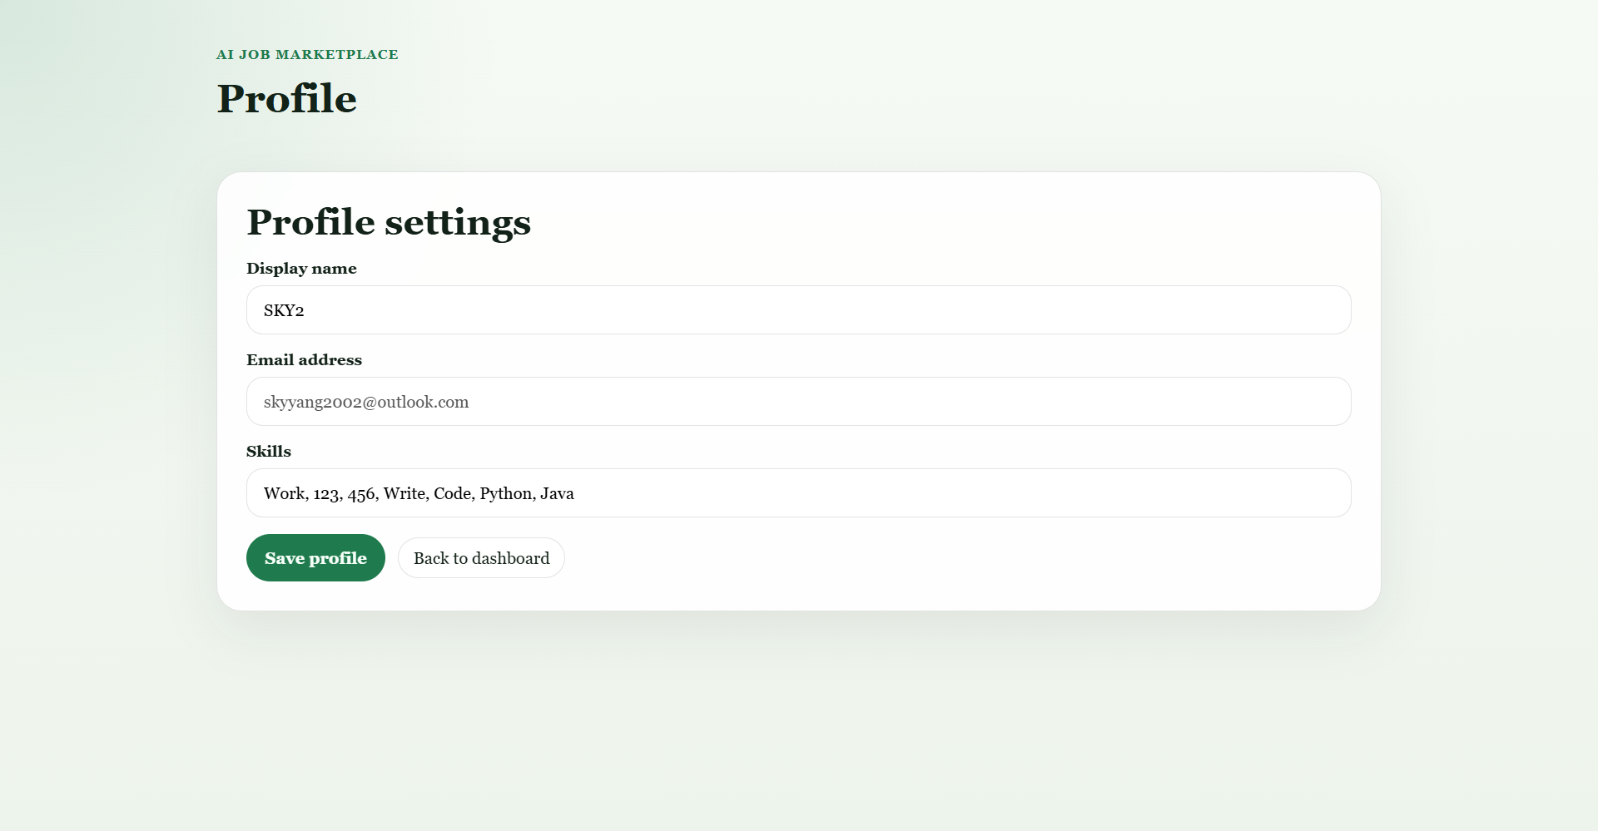
- Server-side job matching
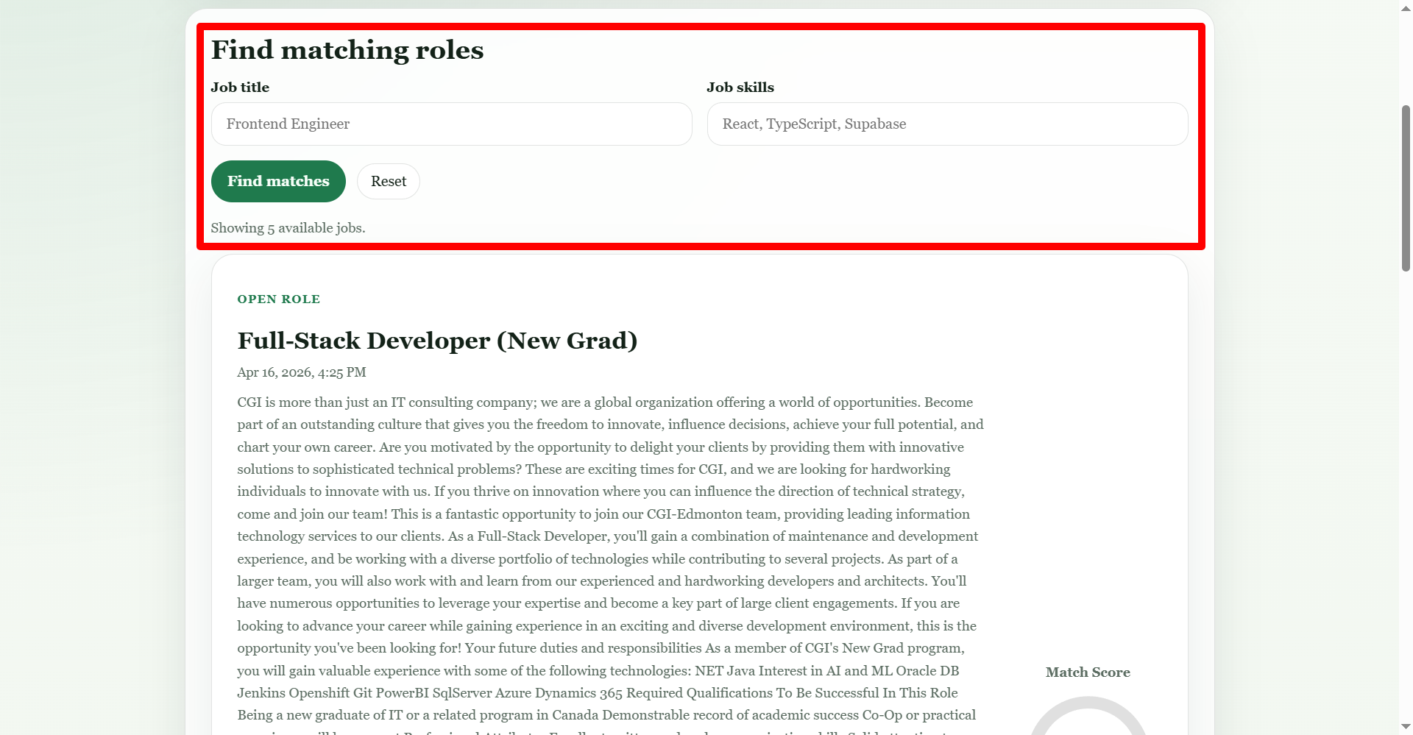
- Match score visualization with gauge chart
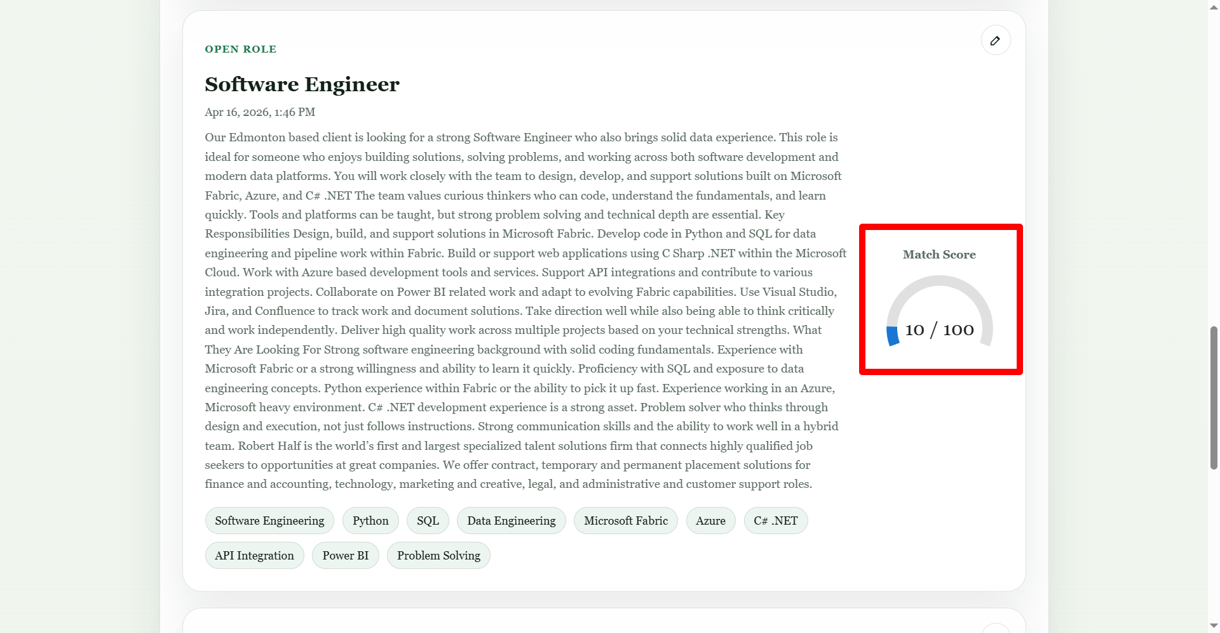
- AI-generated skills for job posting/editing
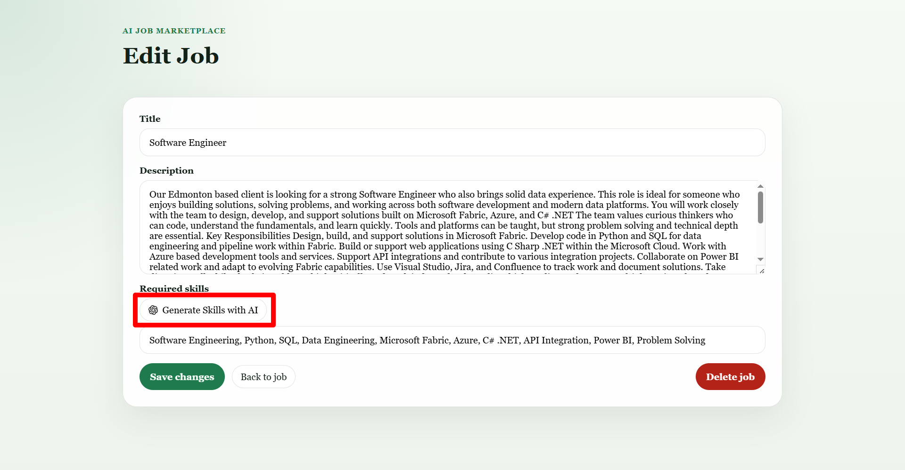
3. AI Usage
AI was used in two stages:
- ChatGPT
  - Used first to analyze the demo requirements
  - Helped define MVP scope, architecture, and feature breakdown
- Codex
  - Used to generate and refine the actual code
  - Helped implement authentication, job CRUD(Create, Read, Update, and Delete), profile, AI skill generation, and UI fixes
Key prompts:
- Create a minimal MVP architecture for an AI job marketplace using Next.js App Router. Include authentication, employer job posting, job browsing, matching logic, and one AI feature.
- Generate a simple authentication system using Supabase in Next.js App Router. Requirements: email/password login, signup page, store user session, redirect after login.
- Create a job posting feature in Next.js. Requirements: title, description, required skills, save to Supabase, API route, validation.
- Display match score for each job card on the right side, use MUI Gauge Chart, and use user profile skills to match job required skills only.
- Fix this Vercel build error: useSearchParams() should be wrapped in a suspense boundary at page "/login".
- Clickable area of AI button on edit and post job page is not match the button, fix this problem.
4. Challenges and Solutions
Challenge 1: Vercel deployment required clean lint/build
Problem:
- Vercel enforced lint and build checks
- Small issues like TypeScript warnings, Suspense errors, and unused variables caused multiple failed deployments
- This required repeated debug and redeploy cycles
Solution:
- Fixed lint/type issues one by one
- Added Suspense boundary for useSearchParams()
- Removed unused variables and implicit any
- Standardized API route typing and auth checks
Prompts that helped:
- Fix these ESLint errors...
- Fix this build error on Vercel...
- Fix this type error: Parameter 'cookiesToSet' implicitly has an 'any' type.
Challenge 2: AI-generated frontend UI was often wrong or misaligned
Problem:
- AI-generated UI sometimes had wrong clickable area, misaligned button positions, and inconsistent card layout
- Some elements looked correct visually but behaved incorrectly
- AI sometimes generated correct logic but weak UI alignment
Solution:
- Refined layout with small targeted prompts instead of regenerating whole pages
- Adjusted CSS step by step
- Separated label/button/input structure when click area was incorrect
- Validated interaction and visual layout together
Prompts that helped:
- Move job-card-score out of job-card-header and put it into job-card-link panel-inner stack
- Tweak the CSS to make the score in the similar position, right middle of the job card
- Clickable area of AI button on edit and post job page is not matching the button, fix this problem

中文
1. 项目架构
这个 Demo 基于 Next.js App Router 构建，是一个全栈 Web 应用。
- 前端：Next.js、React、自定义 CSS
- 后端：Next.js Route Handlers
- 数据库/认证：Supabase
- AI 集成：OpenAI API
- 部署：Vercel
主要模块：
- 用户认证：登录、注册、会话管理
- 控制台：职位匹配、职位列表
- 职位管理：创建、编辑、删除、详情页
- 个人资料：姓名、邮箱、技能
- AI 功能：根据职位描述生成技能
2. 功能
- 邮箱/密码登录注册


- 雇主可创建、编辑、删除职位


- 求职者可浏览职位卡片和职位详情

- 个人资料页可编辑显示名称和技能

- 服务端职位匹配

- 使用仪表盘显示匹配分数

- AI 自动生成职位技能

3. AI 使用方式
AI 在两个阶段被使用：
- ChatGPT
  - 用于前期分析 Demo 需求
  - 帮助梳理 MVP 范围、架构和功能拆分
- Codex
  - 用于实际生成和修改代码
  - 实现了认证、职位增删改查、个人资料、AI 技能生成和 UI 修复
关键提示词：
- Create a minimal MVP architecture for an AI job marketplace using Next.js App Router. Include authentication, employer job posting, job browsing, matching logic, and one AI feature.
- Generate a simple authentication system using Supabase in Next.js App Router. Requirements: email/password login, signup page, store user session, redirect after login.
- Create a job posting feature in Next.js. Requirements: title, description, required skills, save to Supabase, API route, validation.
- Display match score for each job card on the right side, use MUI Gauge Chart, and use user profile skills to match job required skills only.
- Fix this Vercel build error: useSearchParams() should be wrapped in a suspense boundary at page "/login".
- Clickable area of AI button on edit and post job page is not match the button, fix this problem.
4. 挑战与解决方案
挑战 1：Vercel 部署要求 lint/build 全部通过
问题：
- Vercel 会强制检查 lint 和 build
- 一些小问题，如 TypeScript 报错、Suspense 错误、未使用变量，都会导致部署失败
- 因此需要多次调试和重新部署
解决方案：
- 逐个修复 lint/type 错误
- 为 useSearchParams() 增加 Suspense
- 清理未使用变量和隐式 any
- 统一 API 路由和认证检查
使用的提示词：
- Fix these ESLint errors...
- Fix this build error on Vercel...
- Fix this type error: Parameter 'cookiesToSet' implicitly has an 'any' type.
挑战 2：AI 生成的前端 UI 经常出现错位或交互不准确
问题：
- AI 生成的 UI 有时会出现点击区域不对、按钮位置错位、卡片布局不一致
- 有些界面看起来正确，但交互行为不对
- 有些代码逻辑虽然正确，但界面对齐效果不好
解决方案：
- 不一次性重写，而是通过小步迭代优化
- 优先微调 CSS，而不是整块重生成
- 当点击区域异常时，拆分 label/button/input 结构
- 同时检查视觉效果和交互行为
使用的提示词：
- Move job-card-score out of job-card-header and put it into job-card-link panel-inner stack
- Tweak the CSS to make the score in the similar position, right middle of the job card
- Clickable area of AI button on edit and post job page is not matching the button, fix this problem

